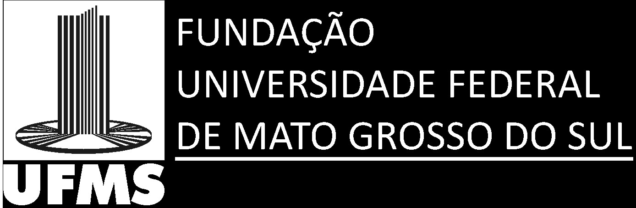
Federal University of Mato Grosso do Sul -UFMS
Campo Grande, MS, 79070-900, Brazil
Phone: +55-67-3345.3068; Fax: +55-67 3345.3068.
Email: rodrigo.oliveira@ufms.br

28th Abril 2016
Dear Editor,

Please find enclosed a manuscript entitled: “A toxicological evaluation of hepatocytes exposed to the synthetic resorcinolic lipid 3-Heptyl-3,4,6-trimethoxy-3H-isobenzofuran-1-one” which I am submitting for exclusive consideration of publication as an article in PECIBES. The paper demonstrates important data that support the view that the resorcinolic lipid derivative is not toxic to the hepatocyte, which therefore could have therapeutic applications. As such this paper should be of interest to a broad readership including those interested in Biology and Medical Sciences. Thank you for your consideration of the study. Please address all correspondence concerning this manuscript to me at my University address or email.
Yours sincerely,
Professor Rodrigo Juliano Oliveira

